Test Case: tc002_SPX_Dev5_Crear_Requisicion_Spot_Tipo_Cobro_Project
Step 1 - Enter username and password and click to button Enter: Credentials Entered
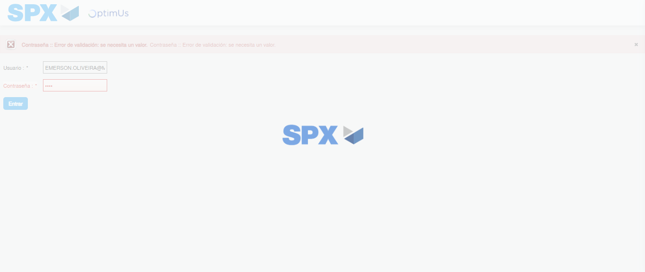Image file-name: QC_Testing-tc002_SPX_Dev5_Crear_Requisicion_Spot_Tipo_Cobro_Project-1785974309148

Step 2 - Select to UEN and Access to Spot Buy Requisitions : UEN Correctly selected and Correct access
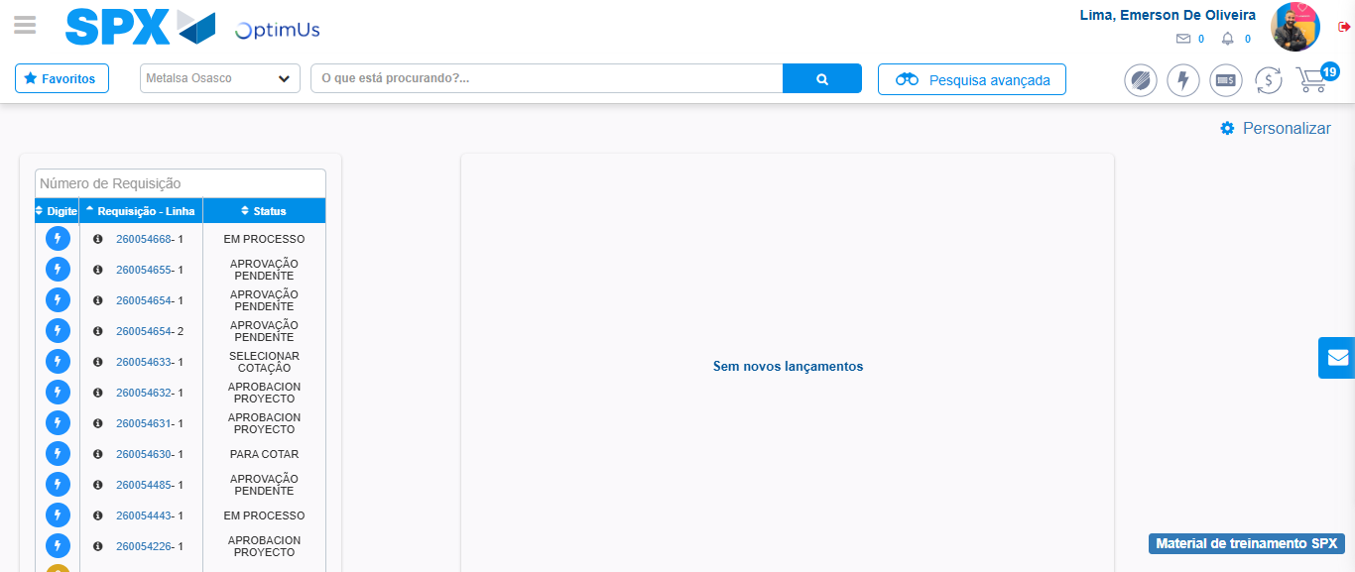Image file-name: QC_Testing-tc002_SPX_Dev5_Crear_Requisicion_Spot_Tipo_Cobro_Project-1785974334174

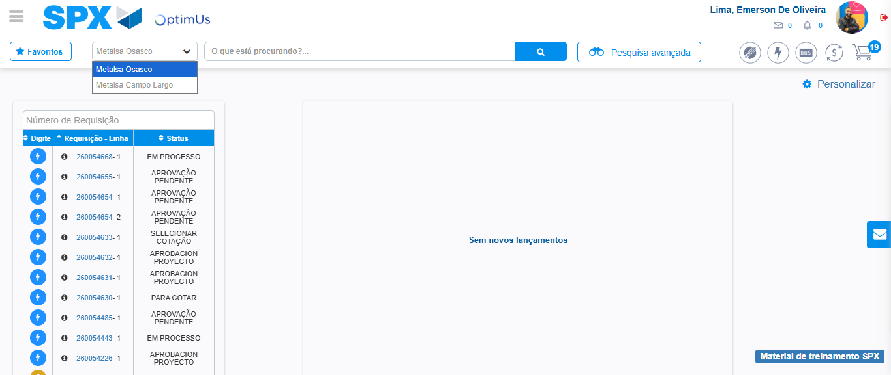Image file-name: QC_Testing-tc002_SPX_Dev5_Crear_Requisicion_Spot_Tipo_Cobro_Project-1785974336644

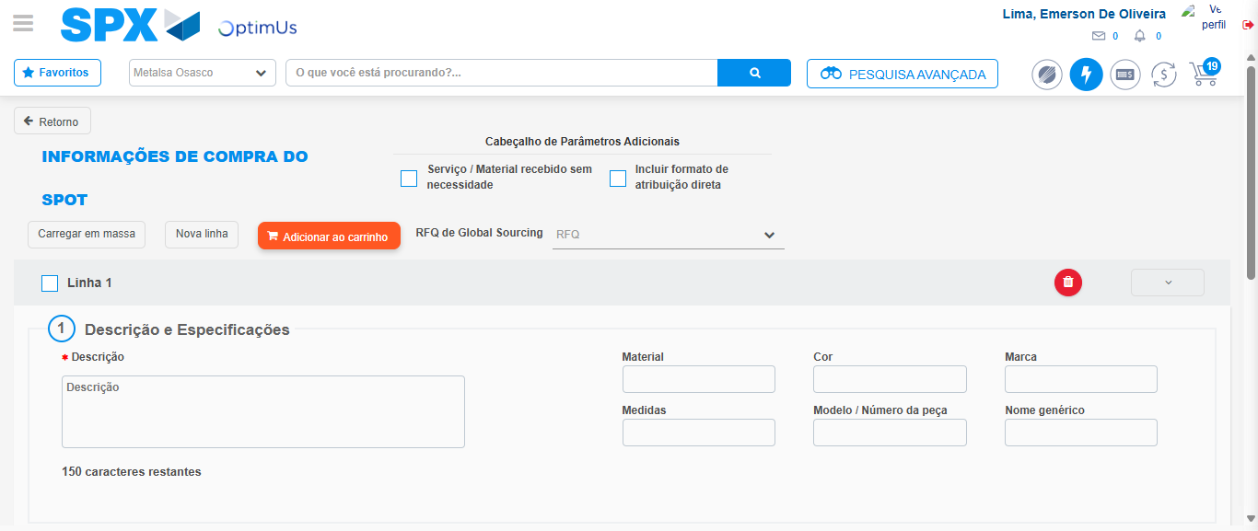Image file-name: QC_Testing-tc002_SPX_Dev5_Crear_Requisicion_Spot_Tipo_Cobro_Project-1785974341353

Step 3 - Data Capture Spot Buy Requisition: Data captured correctly
Image file-name: QC_Testing-tc002_SPX_Dev5_Crear_Requisicion_Spot_Tipo_Cobro_Project-1785974341564

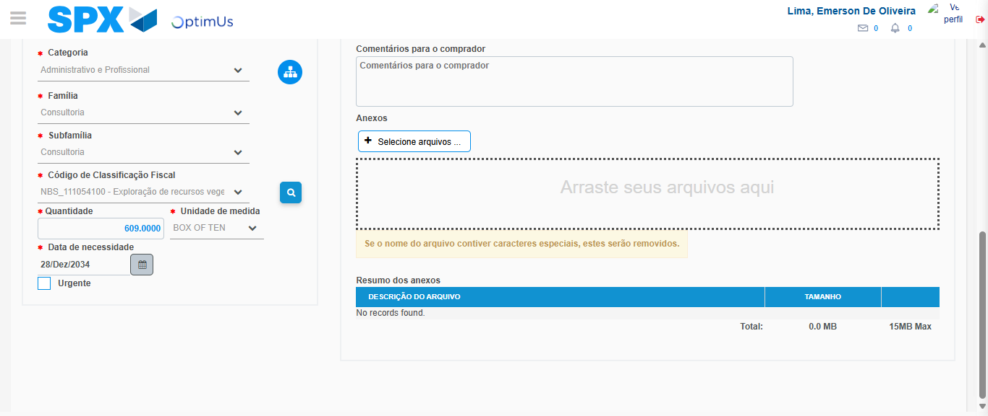Image file-name: QC_Testing-tc002_SPX_Dev5_Crear_Requisicion_Spot_Tipo_Cobro_Project-1785974356873

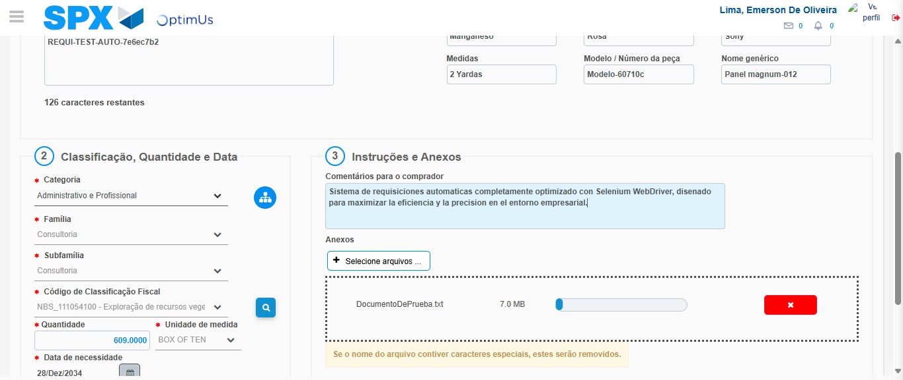Image file-name: QC_Testing-tc002_SPX_Dev5_Crear_Requisicion_Spot_Tipo_Cobro_Project-1785974357595

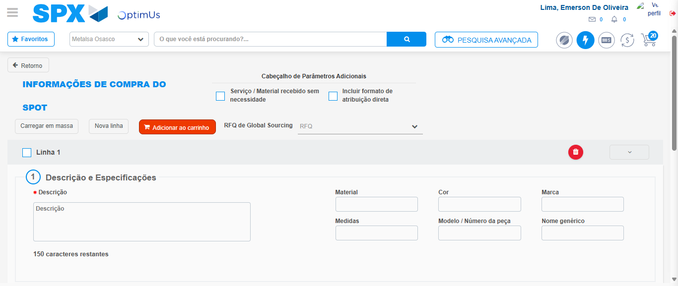Image file-name: QC_Testing-tc002_SPX_Dev5_Crear_Requisicion_Spot_Tipo_Cobro_Project-1785974366212

Step 7 - Return to Main Page SPX : Return to Main Page SPX
Image file-name: QC_Testing-tc002_SPX_Dev5_Crear_Requisicion_Spot_Tipo_Cobro_Project-1785974334174

Image file-name: QC_Testing-tc002_SPX_Dev5_Crear_Requisicion_Spot_Tipo_Cobro_Project-1785974336644

Image file-name: QC_Testing-tc002_SPX_Dev5_Crear_Requisicion_Spot_Tipo_Cobro_Project-1785974341353

Image file-name: QC_Testing-tc002_SPX_Dev5_Crear_Requisicion_Spot_Tipo_Cobro_Project-1785974368453

Image file-name: QC_Testing-tc002_SPX_Dev5_Crear_Requisicion_Spot_Tipo_Cobro_Project-1785974368631

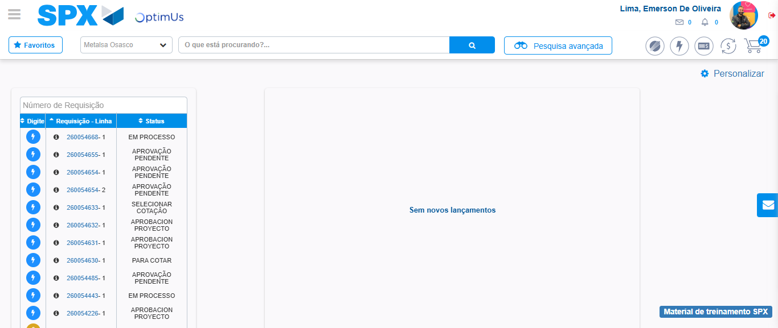Image file-name: QC_Testing-tc002_SPX_Dev5_Crear_Requisicion_Spot_Tipo_Cobro_Project-1785974389634

Step 8 - Log Out : Log Out SPX
Image file-name: QC_Testing-tc002_SPX_Dev5_Crear_Requisicion_Spot_Tipo_Cobro_Project-1785974389809

